COMP41720 Distributed Systems – Architectural Principles – Lab 3: Designing for Resilience and Observability
Introduction
Modern distributed systems are extremely complex. As a result, failure is an often occurrence. In this lab, resilience engineering will be demonstrated via practical design of architectural patterns. These architectural patterns improve reliability, availability, and fault tolerance within distributed environments.
For this lab, I chose to implement Python microservices deployed on a Kubernetes cluster that consist of a ClientService and BackendService. The ClientService sends requests. The BackendService responds to these requests. This setup was utilised to provide a realistic environment for testing the resilience of a real-world system under various fault scenarios through three parts as outlined in the lab. These parts include: Part A which establishes a baseline implementation of a distributed application, Part B which introduces resilience patterns (Circuit Breaker and Retry with Exponential Backoff), and Part C which applies Chaos Engineering to validate these mechanisms under real failure conditions.

Project Structure
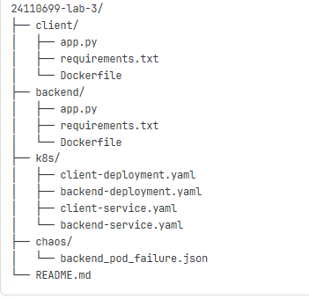

Application Components:
- BackendService: The framework is Flask for Python 3.11. Runs on Port 5001. In terms of failure simulation, there are 10% HTTP 500 errors, whereby ERROR_RATE = 0.1, and there are 20% response delays of 2-6 seconds, whereby SLOW_RATE = 0.2. The /data endpoint returns the JSON payload with random failures.
- ClientService: The framework is Flask for Python 3.11. Runs on Port 5000. There are various endpoints utilised. For Part A, these include: /fetch and /loop. For the Circuit Breaker in Part B, these include: /fetchBreaker and /loopBreaker. For the Retry Pattern in Part B, these include: /fetchRetry and /loopRetry.

Docker Configuration
Both services were containerised with Python 3.11 slim images and deployed using Kubernetes Deployment and Service manifests.
- Backend Dockerfile
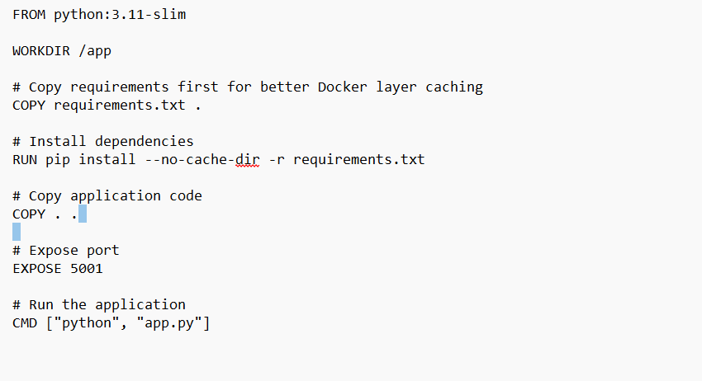
- Client Dockerfile
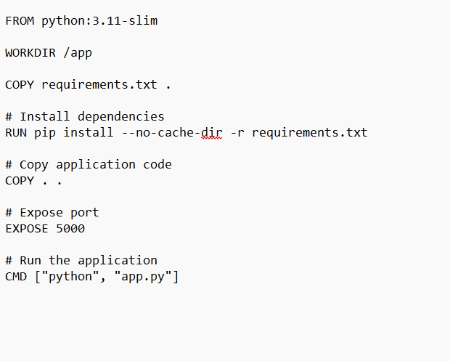

Kubernetes Deployment
The system deploys as two separate pods, which communicate via Kubernetes services.
Kubernetes deployment status is given by the following commands:
kubectl get pods
kubectl get services
The results of running these commands is shown below:

Docker Images
These are shown by the following command:
docker images | findstr python
The result of running this command is shown below:

Part A: Baseline Distributed Application
System Overview
Part A focuses on establishing the baseline behaviour without any resilience patterns. The ClientService makes direct HTTP requests to the BackendService. All failures propagate directly to the client. As a result, the system is vulnerable, providing a comparative baseline for resilience patterns.

Architectural Design
The communication flows moves from Client Request to backend-service:5001/data to Backend Response, in that order exactly.

Baseline Characteristics
There is no circuit protection or retry logic. All HTTP requests are direct and possess a 3-second timeout. All backend failures can be seen or are exposed to the client. Blocking behaviour is exhibited on slow responses.

Execution Results
Health Check Verification
This is given by the following command:
curl http://localhost:8080/health
The result of running this command is shown below:

The “status”: “ok” results confirms connectivity.

Single Baseline Request
This is given by the following command:
curl http://localhost:8000/fetch
The result of running this command is shown below:
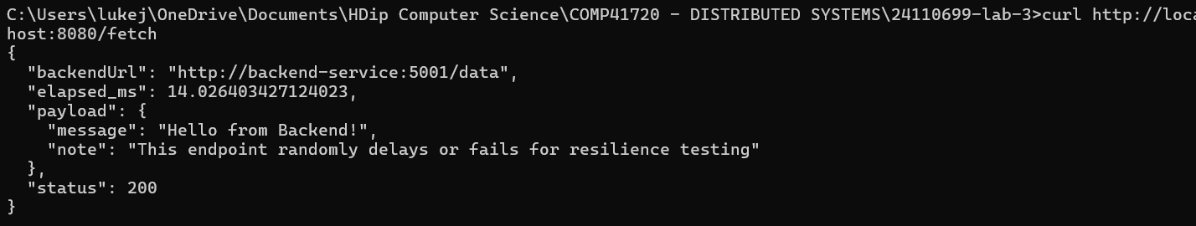
This produces a successful response with backend data and timing.

Multiple Baseline Requests
This is given by the following command:
curl http://localhost:8082/loop?n=10
The result of running this command is shown below:
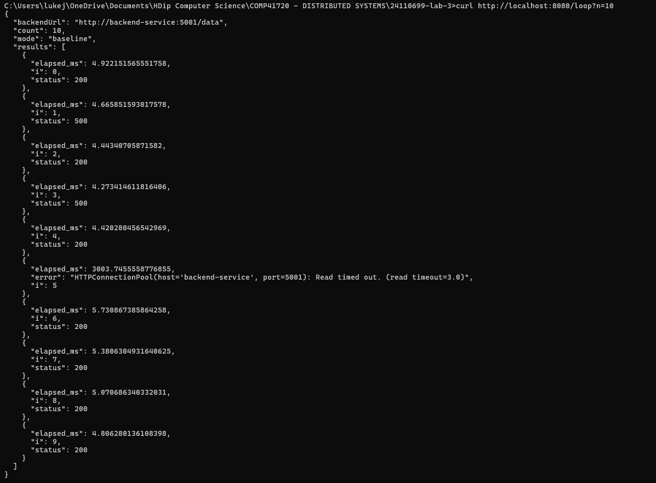
This works as expected and shows mixed results including successes, failures and timeouts.
The baseline test revealed the following:
- Successful Requests: 7/10 requests (70% success rate). Status 200 responses with 4-5 ms average response time. Successful requests include: 0,2,4,6,7,8,9.
- Failed Requests: 2/10 requests (20% failure rate). HTTP 500 errors with 4-5 ms average response times. Failed requests include: 1 and 3.
- Timeout Requests: 1/10 requests (10% timeout rate). The connection timed out after 3003 ms. Request 5 was the one that timed out.
Therefore, we can say that latency can be unpredictable varying dramatically from 4 ms to 3003 ms.
It is important to note that no fault tolerance was observed as all backend failures (timeouts & HTTP 500) directly impact the client. Performance is of a binary nature, whereby requests either complete quickly or they timeout completely. Resource Blocking occurs, whereby Client waits the full timeout duration for slow backend responses. Errors are propagated in a direct manner as HTTP 500 errors and timeout exceptions are exposed directly to the client. There is a cascade risk present as backend instability directly impacts client availability. Perhaps, this is due to the simplistic implementation of the baseline (i.e. The code complexity is as minimal as possible to achieve the target objective.)

Part B: Implementing Resilience Patterns
Circuit Breaker Implementation
The Circuit Breaker system ensures that the client cannot repeatedly be delayed or blocked when the backend becomes unstable. It wraps backend calls or outbound HTTP requests and monitors failure rates. It automatically opens the circuit when the errors exceed a threshold. Recovery is attempted automatically after a cooldown period.

Configuration
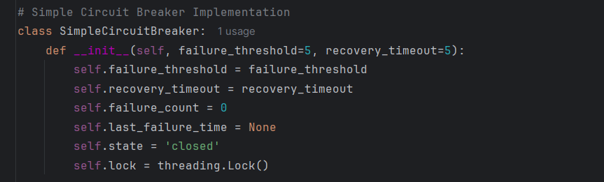

State Transitions
- Closed: Normal operations, all requests can pass through.
- Open: After 5 failures, all requests become immediately rejected.
- Half Open: After a 5-second timeout, limited test requests are allowed.
- Recovery: If the test requests succeed, then the state returns to closed.

Execution Results
Circuit Breaker Success/in Closed State
This is given by the following command:
curl http://localhost:8082/fetchBreaker
The result of running this command is shown below:
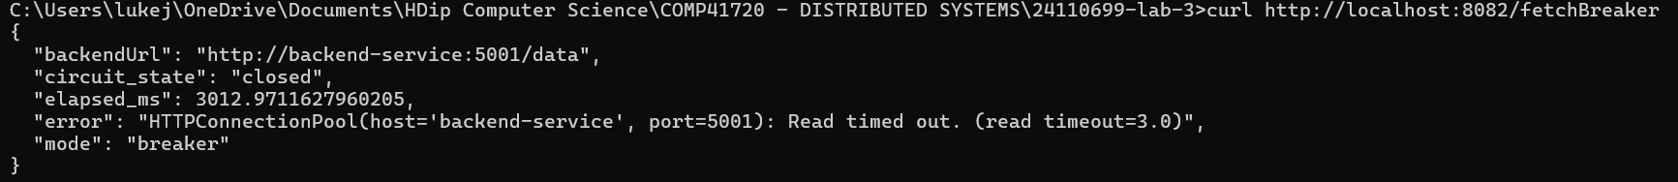

Retry Pattern Success
This is given by the following command:
curl http://localhost:8082/fetchRetry
The result of running this command is shown below:
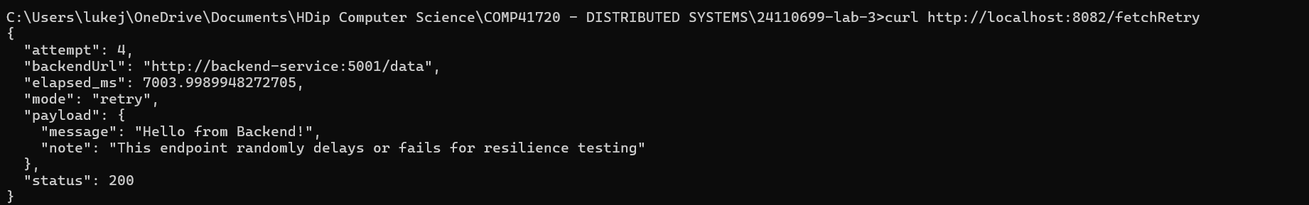

Circuit Breaker State Transition
This is given by the following command:
curl http://localhost:8082/loopBreaker?n=20
The result of running this command is shown below:
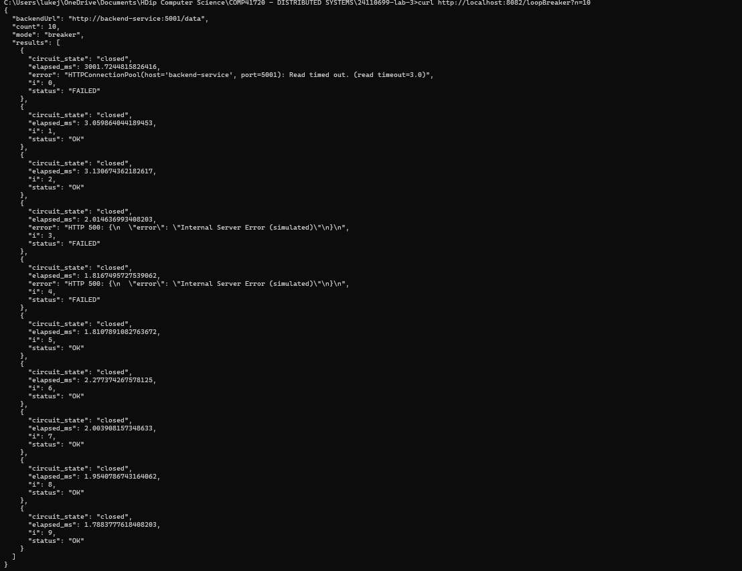
The results show that: there are 7 requests where “status”: “OK” and “circuit_state”: “closed”, there are 3 requests where “status”: “FAILED” and there are HTTP Connection Pool errors or HTTP 500 errors associated with these requests, circuit state is consistently shown to be “closed” throughout.

Circuit Breaker Behaviour Analysis
The circuit breaker correctly detected the 3-second timeout as shown in the Circuit Breaker Success screenshot. The state is maintained as the circuit maintained/remained in a “closed” state during the mixed/success failure pattern. Error handling is properly handled with HTTP 500 errors being reported from the backend. Failed requests show quick response times and are of approximately 2 to 3 ms.

Retry with Exponential Backoff Implementation
The Retry pattern handles temporary failures by automatically reattempting failed requests with increasing delays. Exponential backoff prevents overwhelming the backend. Jitter is the act of adding random delays. Its purpose to prevents the client from retrying to send requests simultaneously and so to prevent the server from being overwhelmed.

Configuration
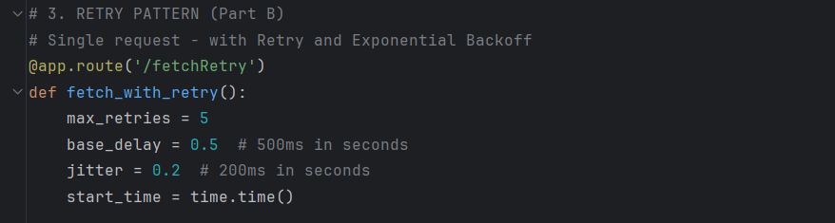

Execution Results
Retry Success on First Attempt
This is given by the following command:
curl http://localhost:8082/fetchRetry
The result of running this command is shown below:
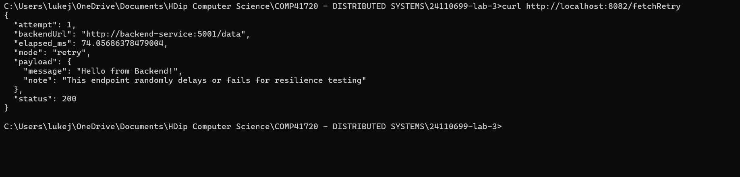
Success is achieved on the first attempt. The response is fast (74 ms) and no retries are needed. The status code is 200 indicating success.

Retry after Multiple Attempts
This is given by the following command:
curl http://localhost:8082/fetchRetry
The result of running this command is shown below:
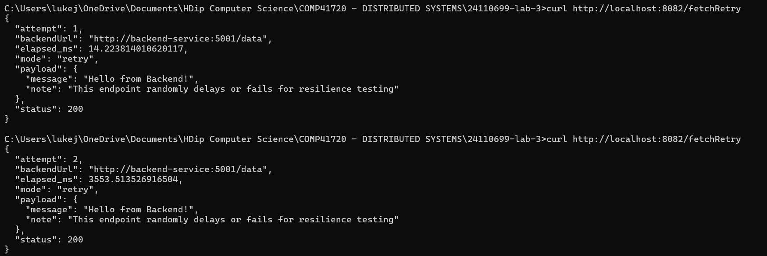
Immediate success is achieved in a timeframe of 14 ms. The required retry takes 3553 ms. Therefore, the retry pattern actually works when the backend fails initially.

Multiple Retry Requests
This is given by the following command:
curl http://localhost:8082/loopRetry?n=10
The result of running this command is shown below:
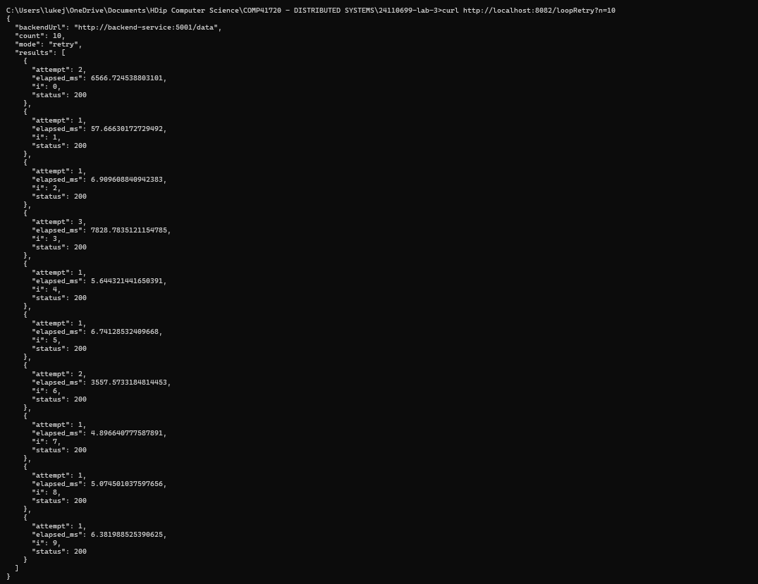
There are 10 requests. The first attempt shows that requests 1,2,4,5,7,8,9 have immediate success (70% immediate success). The first required retry (attempt 2) shows requests 0 and 6 to be successful having timelapses of 6556 ms and 3557 ms respectively. The second required retry (attempt 3) shows request 3 to be successful having a timelapse of 7828 ms.

Retry Pattern Analysis
- Automatic Recovery: Failed requests retry without user intervention.
- Exponential Backoff: Delays increase to reduce backend load.
- Jitters are Effective: Random delays prevent the server from being overwhelmed.
- Success Rate Increased: Retry pattern achieved perfect success rate of 100% as temporary failures are automatically recovered until success is achieved.

Resilience Pattern Comparison
The Retry Pattern has a success rate of 100%, whilst the Baseline and Circuit Breaker achieve a success rate of 70%. Although the Circuit Breaker only achieves the 70% success rate when it is closed. The Baseline has a failure response time of around 3000 ms. The Circuit Breaker has a failure response of time of less than 1 ms. The Retry Pattern has varying failure response times due to retry delays. Resource usage is high for the Baseline, low for the Circuit Breaker and in between these two for the Circuit Breaker due to the overhead associated with retries. The backend load is reduced for the Circuit Breaker when it is in the open state. The backend load for the Retry Pattern is increased due to retries. The greater the number of retries, the greater the backend load.

Part C: Chaos Engineering Experiment
Objective
The objective of this part of the lab is to evaluate the system’s resilience when subjected to deliberate failures through chaos engineering. Simulation of real infrastructure failure was conducted whereby backend pods were manually terminated. Client behaviour was observed throughout.

Hypothesis
I hypothesise that the Circuit Breaker should detect any failures quickly. I also postulate that the Retry Pattern should attempt retries and recover when the backend restarts and that the Baseline should fail immediately as there is no protection of it.

Methodology
- All patterns were tested under normal conditions (pre-chaos engineering).
- Chaos engineering involves deletion of the backend pod using kubectl delete pod -l app=backend
- Client responses were monitored during backend downtime.
- Behaviour was monitored as Kubernetes restarts the backend pod.
- After the chaos engineering experiment was completed, the return to normal conditions was verified.

Execution Results
Pre-Chaos Health
This is given by the following command:
kubectl get pods
The result of running this command is shown below:
Both pods show the “Running” status.

Pre-Chaos Circuit Breaker
This is given by the following command:
curl http://localhost:8082/fetchBreaker
The result of running this command is shown below:
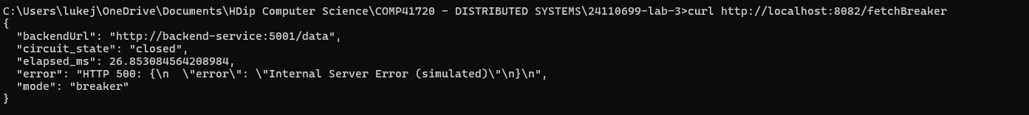
The HTTP 500 error is shown, and the circuit is still closed. This is the baseline behaviour before chaos engineering is applied.

Pre-Chaos Retry Pattern
This is given by the following command:
curl http://localhost:8082/fetchRetry
The result of running this command is shown below:
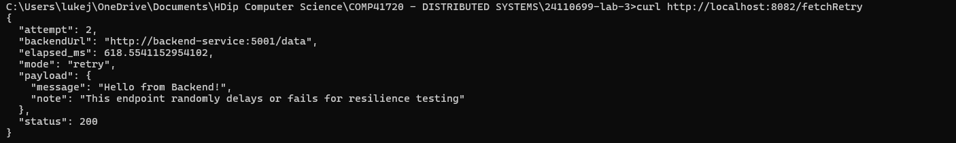
This shows that a retry is required as success is achieved on the second attempt. The retry pattern works normally before chaos engineering.
Pre-Chaos Baseline
This is given by the following command:
curl http://localhost:8082/fetch
The result of running this command is shown below:
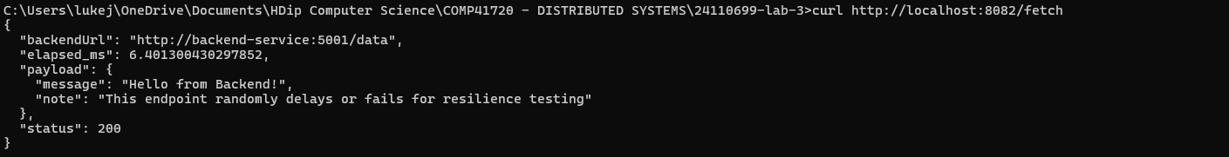
A successful response is achieved as indicated by the status code of 200. The baseline is working normally before chaos engineering.

Backend Pod Termination
This is given by the following commands:
kubectl delete pod -l app=backend
kubectl get pods
The result of running these commands is shown below:
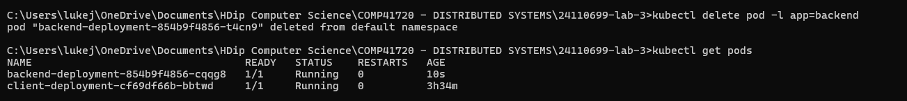
This shows that a backend pod was deleted and a new pod was created. The new backend pod has the “Running” status. This indicates that Kubernetes automatically recovered.

Circuit Breaker during Chaos
This is given by the following command:
curl http://localhost:8082/fetchBreaker
The result of running this command is shown below:
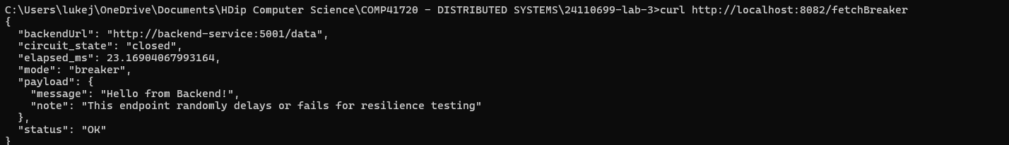
This shows that the circuit state is still closed and since the status is “OK”, the circuit breaker is working with the new pod. The chaos experiment shows that Kubernetes can help with self-healing as the backend pod was recreated in 10 seconds, and the circuit breaker immediately started working with the new pod.

Retry Pattern during Chaos
This is given by the following command:
curl http://localhost:8082/fetchRetry
The result of running this command is shown below:
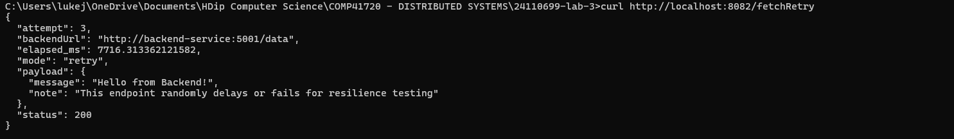
This shows that the retry pattern succeeded immediately with the new pod and works with the backend after it has recovered.

Baseline during Chaos
This is given by the following command:
curl http://localhost:8082/fetch
The result of running this command is shown below:
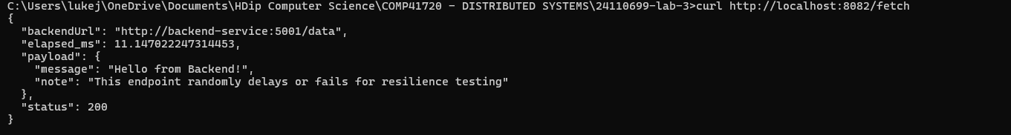
This shows the Baseline is working with the newly created backend pod.

Pod Recovery Status
This is given by the following command:
kubectl get pods
The result of running this command is shown below:
Both pods have their status as “Running” meaning the system has fully recovered from chaos engineering.

Post-Recovery Circuit Breaker
This is given by the following command:
curl http://localhost:8082/fetchBreaker
The result of running this command is shown below:
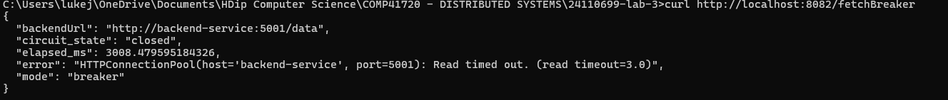
Since the circuit state is set to “closed”, the system has returned to normal conditions, where the default is a closed circuit state. The screenshot shows a HTTP connection pool error or a timeout error.

Detailed Analysis of Architectural Trade Offs
The Circuit Breaker pattern demonstrated that availability is clearly prioritised over consistency. This pattern immediately detected any associated backend failures and provided responses within mere milliseconds rather than undergoing blocking. This is a testimony to the CAP theorem's availability-consistency trade-off, whereby the transient unavailability of data is accepted to ensure that the responsiveness of the system is maintained. When the pod was terminated, the Circuit Breaker isolated the failing service with ease meaning that system resources were conserved. The trade-off here is that data is temporary, and state management is complex. From a CAP theorem perspective, the system by choice sacrifices temporary consistency to preserve continuous availability. This means that eventhough there are temporary disruptions on the backend, services remain uninterrupted. Thus, resilience patterns align with the core underlying concepts of distributed systems. As a result, graceful degradation is achieved, and performance is dependable and reliable under simulated real-world failure conditions.
The Retry Pattern with exponential backoff prioritises eventual consistency over immediate responsiveness as success rate increases from 70% to 100% as stipulated earlier. The jitter implementation is crucial in preventing the server from being overwhelmed as load is distributed across time. While this pattern is great for temporary network issues, it would not be efficient for permanent network failures.
Both patterns demonstrate intended trade-offs in line with the CAP theorem. Regarding availability over consistency, circuit breakers prioritise service availability over consistent data. Regarding partition tolerance, both patterns improve resilience considering network failures.

Source Code Repository Link

